Dining in Kitsap County: As Told by PNWT Staff

At Pacific Northwest Title, we love where we live and want to share it with everyone! Kitsap county has an amazing food industry and we decided to highlight some of our favorites. We asked everyone in the office what dining establishments they loved and compiled it into this list. Some are packed and popular and others are hidden gems, but each has a special story, something to offer the community, and, of course, delicious food!

BREAKFAST AND LIGHT FARE

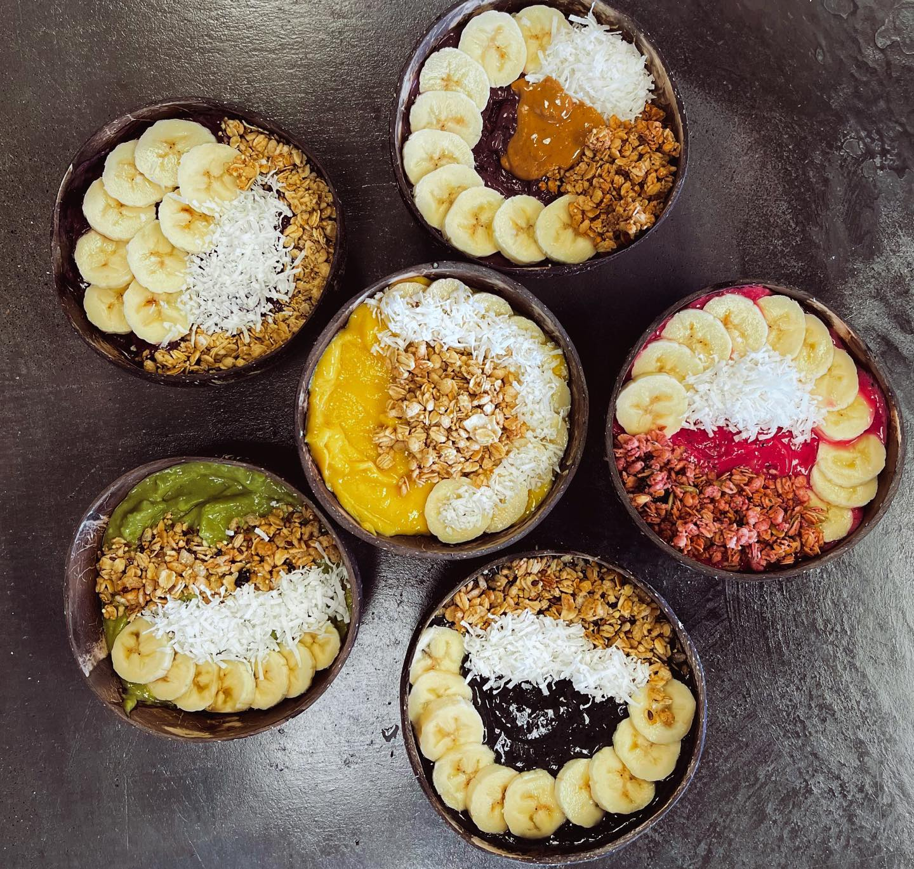
PHOTO: MOVE Facebook
MOVE
https://www.facebook.com/brookebrwn | 10876 Myhre Pl NW, Silverdale, WA 98383
This is more than just your average smoothie and juice bar- they serve hot and iced coffee, fresh acai bowls, shakes and smoothies, and even waffles! MOVE is a family-owned business, “passionate about bringing the community healthy alternatives.” So, whether it’s a blueberry waffle topped with lemon cashew drizzle, blueberries, and whip cream, a chocolate peanut butter supreme acai bowl, or just a simple latte, MOVE is there to satisfy your healthy cravings.

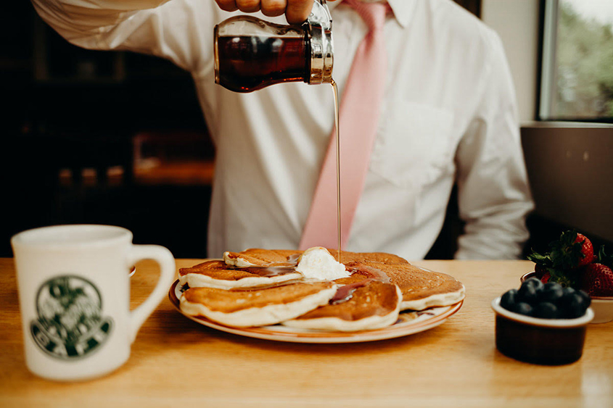
PHOTO: The Oak Table Cafe
The Oak Table Cafe
http://www.oaktablecafesilverdale.com/ | 3290 NW Mt Vintage Way, Silverdale, WA 98383
This breakfast joint originated in Sequim, WA 40 years ago by the parents of Nikki and Ross who now own and run this family restaurant. The Oak Table places a strong emphasis on great staff, memorable positive experiences, and warm hospitality. From their handmade, not from the box batter, their old-fashioned sourdough barrel, their from-scratch syrups and toppings recipes, and their daily fresh-squeezed juices and lemonade, you are sure to feel right at home.

AMERICAN

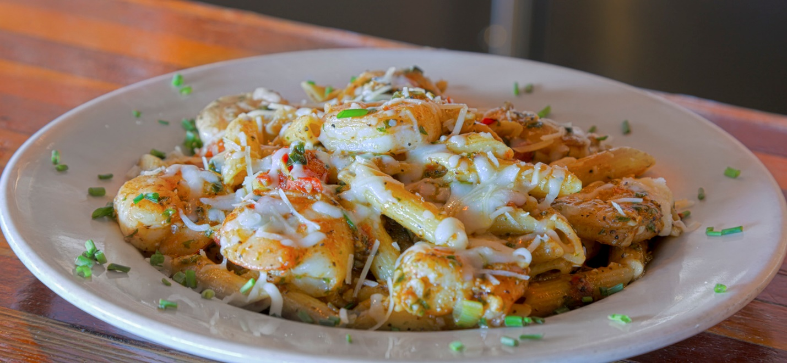
PHOTO: Yacht Club Broiler
Yacht Club Broiler
https://yachtclubbroiler.us/ | 9226 Bay Shore Dr NW, Silverdale, WA 98383
This restaurant, which sits on Dyes Inlet, has large, open windows and a patio overlooking the Silverdale waterfront. Conveniently located within walking distance from the marina and old town Silverdale, this is the perfect place to enjoy the water and then take a stroll, exploring the local area. Their menu features items such as “prime steaks, the freshest seafood selections, pastas, and much more.”

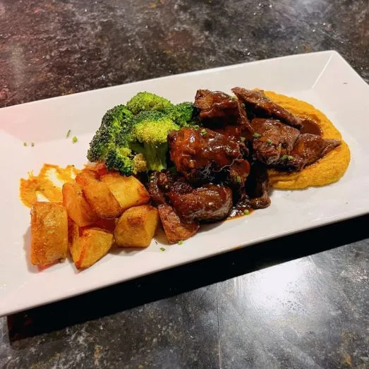
PHOTO: Crabtree Kitchen + Bar Beef Confit
Crabtree Kitchen + Bar
https://www.crabtreekitchen.com/ | 19225 8th Ave NE #200, Poulsbo, WA 98370

Serving dinner Wednesday through Saturday and brunch on Sundays, Crabtree Kitchen and Fare is all about supporting local community and farmers to bring the best, freshest ingredients of the Pacific Northwest to you. They have also been raising their own beef for over 70 years in northern Kitsap County, all to “encourage [their] vision of sustainable agriculture.” This beef is served in their restaurant and can even be bought in their marketplace.

MEXICAN & EL SALVADORIAN

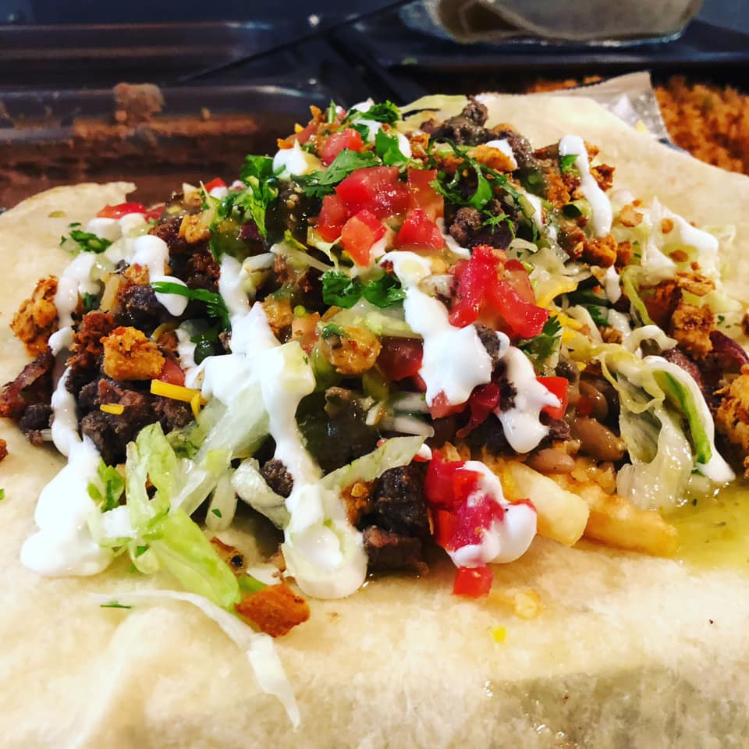
PHOTO: El Balcon Facebook – Big Boy burrito with asado, chicken, chorizo, bacon, fries, fresh veggies, sour cream, cheese, and salsa
El Balcon
https://www.facebook.com/Bremelbalcon/ | 190 Pacific Ave, Bremerton, WA 98337
This family-owned, Mexican and Salvadoran restaurant provides an authentic taste of Mexico and El Salvador. You can expect to find classic dishes like pupusas, pastelitos, tacos, burritos, and tortas. Burritos and tortas come in several combinations, including asada, chicken, chorizo, chipotle, California, Hawaiian, and more. When you’re done, savor it with a refreshing Jamaica or horchata!

VIETNAMESE

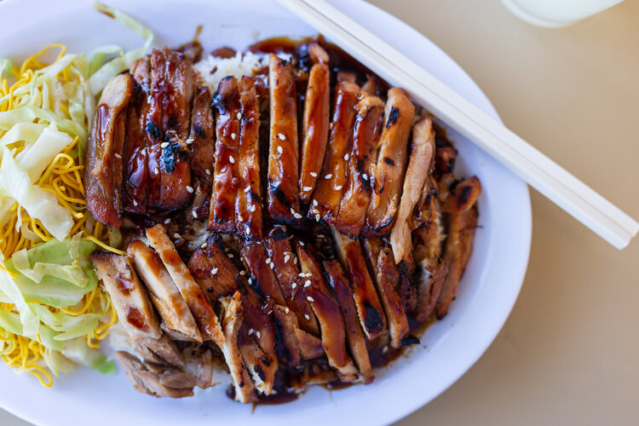
PHOTO: Chung’s Teriyaki
Chung’s Teriyaki
https://www.chungsteriyaki.com/ | 3111 NW Bucklin Hill Road, Silverdale, WA 98383
Owner Chung Nguyen brought the “simple but fresh dishes of home in Vietnam” to the U.S after the fall of South Vietnam in 1975. He was “forced to flee” and “[was packed] onto an overloaded wooden boat with hundreds of other refugees.” When he was accepted into the U.S., he was sponsored by a family in Kitsap and has been here ever since. The original Chung’s opened in Poulsbo in 1994 but now his secret teriyaki sauce and “tantalizingly complex Pho soup recipe” can be enjoyed in Silverdale and Downtown Bremerton as well.

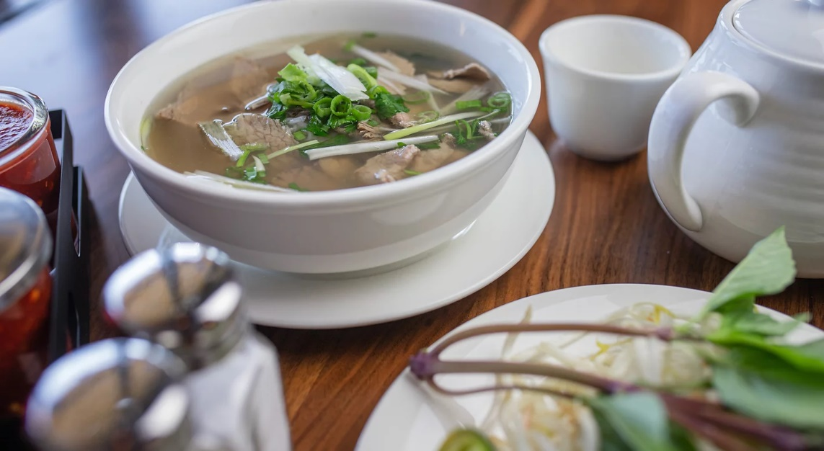
PHOTO: Green Garden Pho
Green Garden Pho
https://www.greengardenpho.com/ | 10516 Silverdale Way NW, Silverdale, WA 98383
For the patron looking for a healthy option, Green Garden Pho boasts healthy dining open seven days a week. Enjoy traditional Vietnamese pho with “grandma recipes slow cooked broth, [the] thinnest fresh rice noodle, fresh vegetables, [and] rich nutrient herbs.” They also offer bun (or vermicelli rice noodles), a variety of wok dishes and wok fried noodles, curry, vegetarian options, and more.

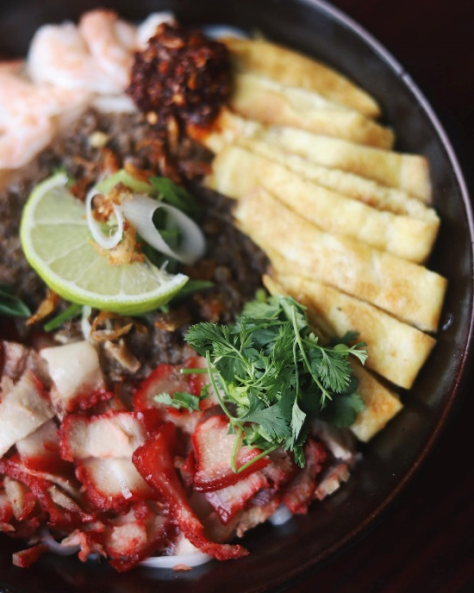
PHOTO: Pho T&N Facebook: Dry Noodle Bowl, consisting of egg, shrimp, ground beef & pork belly with a side of chicken broth

Pho T&N
https://www.photnpoulsbo.com/ | 19641 7th Ave NE #135, Poulsbo, WA 98370
Founders Rang Nguyen and Huyen Tran travelled to Seattle in 1998. From humble beginnings “selling Bahn Mi to butchering meat in the refugee camp,” to then “working in various kitchens throughout Seattle,” they finally were able to accomplish their dream to own a business in America. Now operated by the second generation of the Nguyen family, you can experience dishes such as beef stew, pho soup, a variety of noodle bowls and rice dishes, and an array of vegan dishes.

THAI

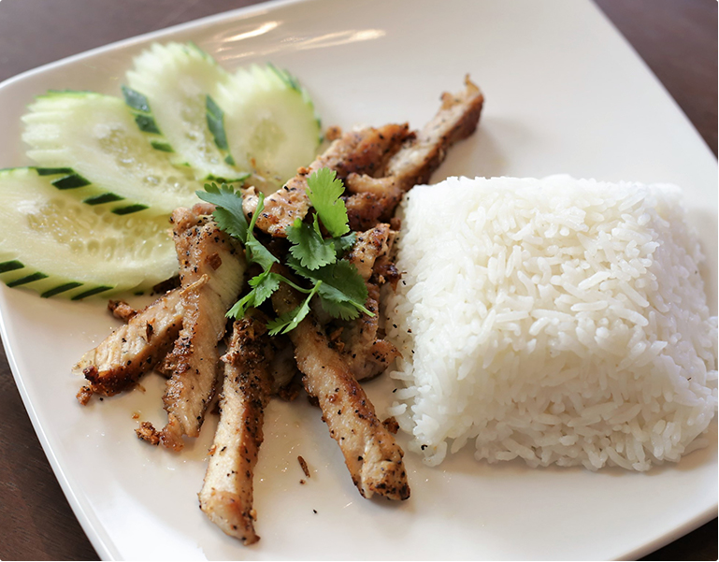
PHOTO: Family Thai Cuisine
Family Thai Cuisine
http://www.familythaicuisine.com/ | 9601 Mickelberry Rd NW #111, Silverdale, WA 98383
Family Thai Cuisine’s offers the “liveliness and excitement of [their] exhibition kitchen” with the freshest and finest ingredients. Their extensive menu offers an array of appetizers such as pot stickers, spring rolls, and chicken satay, fresh salads and soups such as larb and pho, a variety of curries and noodle dishes, fried rice dishes, and chef specialties such as crispy orange chicken, basil mango, and seafood golden pot. But save room for traditional Thai desserts like sangkaya!

KOREAN

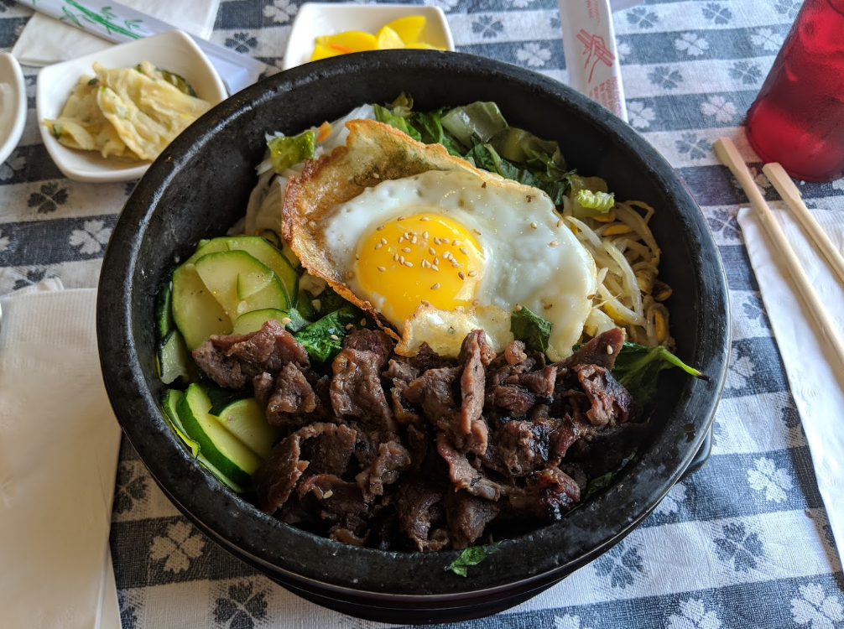
PHOTO: Suzy’s Kitchen Google Reviews by M Karv
Suzy’s Kitchen
https://suzyskitchen.net/ | 2665 6th St, Bremerton, WA 98312
This relaxed mom-&-pop restaurant has something for the whole family! Whilst they specialize in Korean BBQ plates such as bulgogi and kalbi, they have a wide variety of Korean and American dishes available. Whether you’re in the mood for bibimbap, spicy ramen, and teriyaki bowls or Suzy’s home-made meatloaf, BBQ garlic wings, and country fried steak, there is bound to be something for everyone on this extensive menu!

COFFEE, PASTRYS, & DESSERT

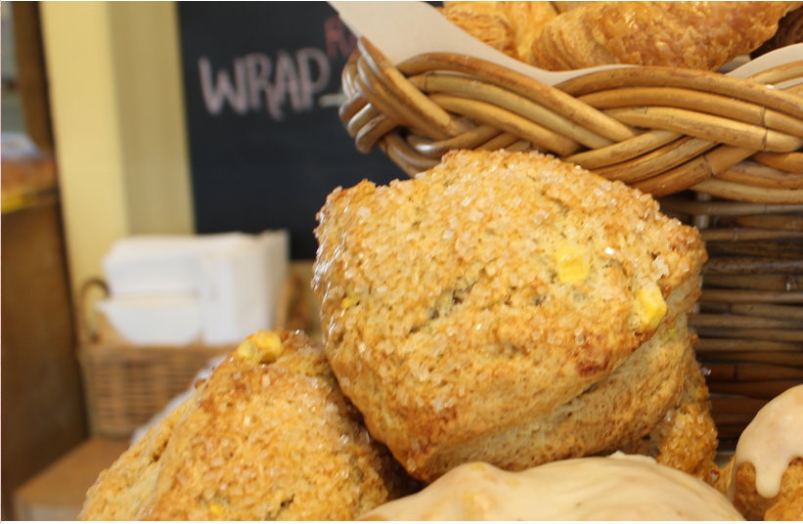
PHOTO: Monica’s Waterfront Bakery & Cafe
Monica’s Waterfront Bakery & Cafe
https://monicascafe.com/ | 3472 NW Byron St, Silverdale, WA 98383
This down-to-earth café is all about being “sustainable and responsible,” which is why they engage with the community and participate in environmentally conscious practices. Working with Silverdale organic farmer Paul Gregory, their ingredients are sure to be fresh and in season. Plus, all their food waste goes right back to Paul for compost on his farm! This is just one example of so many, but whether it’s working with local, often family-owned businesses, reducing their carbon footprint, or donating food to local charities, Monica’s is “known for thinking globally and acting locally.”

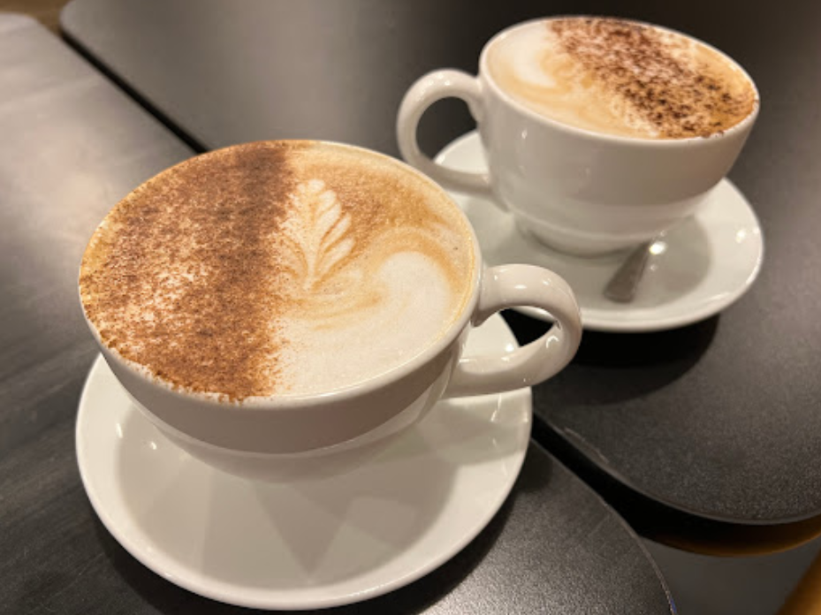
PHOTO: Café Corvo Google Reviews – Everett White
Café Corvo
http://cafe-corvo.com/ | 629 N Callow Ave, Bremerton, WA 98312
This café offers “coffee, espresso, and a neighborly atmosphere with pastries from your favorite local bakers.” Café Corvo’s menu includes an array of quality drink options like americanos, breves, chai tea, London fog, cold brew, drip coffee, and so much more. Not only are they providing great beverages, but they also believe in helping build up Bremerton’s community and work with vendors within 25 miles as often as possible.

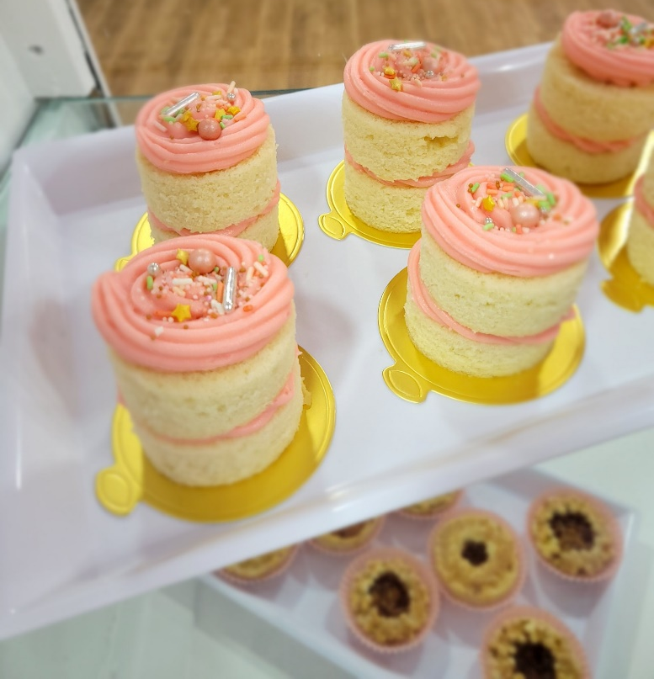
PHOTO: Crazy for Confectionary Facebook
Crazy for Confectionary
https://www.facebook.com/crazyforconfectionary/ | 214 Burwell St, Bremerton, WA 98337
This super fun bakery offers a different menu every day! They even have options for those with specialty dietary needs because they believe “everyone should be able to have their cake and eat it too.” From past menus, Crazy for Confectionary has served delicious desserts such as white velvet mini cakes, chocolate shortbread cookies, gluten free lemon pound cake, and vegan peach mini pies. Stop by their Facebook page whenever you get a craving to catch the latest daily menu!

With so many delicious options, it’s difficult to choose, but one thing is for certain- we are grateful to have so many in our back yard. The cultural diversity, community involvement, quality ingredients and techniques, and the years dedicated to each establishment’s dreams and goals is inspiring. This past couple of years has been difficult for everyone and our local businesses have felt the impact in a huge way. That’s why they need our help as we move forward. The next time you’re dining out, think about supporting local and giving back to the home we love so much!

